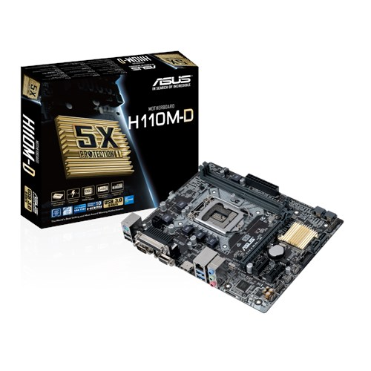MOTHERBOARD – ASUS H110M-D

INTEL CORE i3-7100 3.9Ghz (2 CORES)

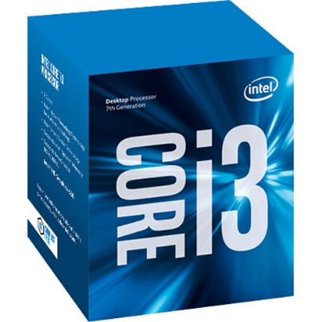

4GB DDR4-2400 Kingston KVR24N17S8/4

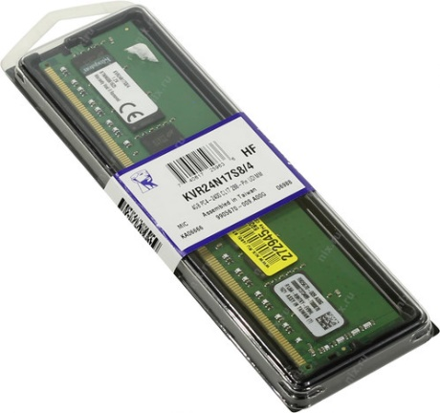

SECURE UPS-650Va Uninterruptible Power Supply (Black)

